Poultry Farm Management System



Muhammad Izaz Khan

Roll no: 589

BS software engineering

Session 2015-19

Department of Software Engineering

University of Malakand

Khyber Pakhtunkhwa, Pakistan

Poultry Farm Management System

This Poultry Farm Management System is submitted in partial fulfillment of requirements for the degree of Bachelor in Software Engineering to the Department of Software Engineering, University of Malakand as on

Submitted by: Muhammad Izaz Khan_____

Supervisor: Engr: Abdurrahman

Chairman Department of Software Engineering: Dr:Khalil

Certificate of Approval

It is certified that we have studied this project report submitted by Muhammad Izaz Khan in detail. We conclude that this report is of sufficient standard to warrant its acceptance by the department of Software Engineering for the award of the degree of   
BS in Software Engineering.

Supervisor

Signature:

Name:

Designation:

External Examiner

Signature:

Name:

Designation:

Institute:

Chairman Software Engineering

Signature:

Name:

**DEDICATION**

This project is wholeheartedly dedicated to our beloved parents, who have been our source of inspiration and gave us strength when we thought of giving up, who continually provide their moral, spiritual, emotional, and financial support.

To our brothers, relatives, friends, and classmates who shared their words of advice and encouragement to finish this project.

And lastly, I would like to dedicate this project to Almighty Allah that gave great health upon me in the struggle to accomplish my goals in this project. And I greatly thank my supervisor Engr. Abdurrahman Department of Software Engineering, University of Malakand. He guided me Encouraged me, for his help, advice and every correction of the way. I am also grateful to all my teachers.

**ACKNOWLEDGEMENTS**

The success and final outcome of this project required a lot of guidance and assistance from many people and I am extremely privileged to have got this all along the completion of my project. All that I have done is only due to such supervision and assistance and I would not forget to thank them.

I respect and thank Engr. Abdurrahman, for providing me an opportunity to do the project work in "Poultry Farm Management System" and giving us all support and guidance which made me complete the project duly. I am extremely thankful to him for providing such a nice support and guidance, although he had busy schedule managing the corporate affairs.

I am thankful to and fortunate enough to get constant encouragement, support and guidance from all Teaching staffs of Department of Software Engineering which helped us in successfully completing our project work. Also, I would like to extend our sincere esteems to all staff in lab for their timely support.

**Abstract**

“Poultry Farm Management System” is developing for giving various information about poultry form. This application is mainly for the maintenance and management of the poultry farm. It maintain the record systematically and enable us to give the information on the time. Sales and expense record as well as profit and loss calculations require a lot of time to go through all transactions. Poultry rec. is poultry management software which will overcome all of these problems and Provide additional functionalities.

**Contents**

**CHAPTER 1 ----------------------------------------------------------------------------------------------------------- 1**

**1.** **SYSTEM INTRODUCTION --------------------------------------------------------------------------------- 1**

1.1. OVERVIEW ------------------------------------------------------------------------------------------------------------ 1

1.2. Poultry Form: Business Field ---------------------------------------------------------------------------------------------- 1

1.3. The Idea---------------------------------------------------------------------------------------------------------- 1

1.4. Problem Statement--------------------------------------------------------------------------------------------------- 2

1.5. Proposed Solution --------------------------------------------------------------------------------------------------- 2

1.6.Project Scope **----------------------------------------------------------------------------------------------------**2

1.7. Main Modules -------------------------------------------------------------------------------------------------------- 3

1.7.1. Login/Register ---------------------------------------------------------------------------------------- 3

1.7.2. Stock Management --------------------------------------------- ------------------------------------- 3

1.7.3. Purchase Management ------------------------------------------------------------------------------- 3

1.7.4. Sale Management ------------------------------------------------------------------------------------ 4

1.7.5. Consumption Management -------------------------------------------------------------------------- 4

1.7.6. Reports Management --------------------------------------------------------------------------------- 4

1.7.7. Employee Management ------------------------------------------------------------------------------ 4

**CHAPTER 2 ---------------------------------------------------------------------------------------------------------- 5**

**2.1 SYSTEM ANALYSIS ------------------------------------------------------------------------------------------ 6**

2.2 Use Cases ------------------------------------------------------------------------------------------------------------- 6

2.3 Actors ----------------------------------------------------------------------------------------------------------------- 6

2.4 USE CASES Diagram-------------------------------------------------------------------------------------------------- 7

2.5 Use Case description in brief format-------------------------------------------------------------------------------8

2.5.1 Login/Register ------------- ------------------------------------------------------------------------------------ 8

2.5.2 Stock ------------------------------------------------------------------------------------------------------------- 8

2.5.3 Purchase - --------------------------------------------------------------------------------------------------------8

2.5.4 Sale -------------------------------------------------------------------------------------------------------------- 8

2.5.5 Consumption --------------------------------------------------------------------------------------------------- 8

2.5.6 Employee ------------------------------------------------------------------------------------------------------- 9

2.5.7 Report ------------------------------------------------------------------------------------------------------------9

2.6 Detailed Use Cases --------------------------------------------------------------------------------------------------9

2.6.1 Login/Register --------------------------------------------------------------------------------------------------9

2.6.2 Stock--------------------------------------------------------------------------------------------- 10

2.6.3 Purchase ------------------------------------------------------------------------------------------------- 10

2.6.4. Sale------------------------------------------------------------------------- 11

2.6.5. Consumption ---------------------------------------------------------------------- 12

2.6.6. Reports ---------------------------------------------------------------------- 12

2.6.5. Employee ---------------------------------------------------------------------- 13

2.7. Sequence Diagram ------------------------------------------------------------------------------------------------- 14

2.7.1 Login/Register ------------------------------------------------------------------------------------------------ 14

2.7.1.1 Register ---------------------------------------------------------------------- 14

2.7.1.2 Login ---------------------------------------------------------------------- 15

2.7.2 Stock --------------------------------------------------------------------------------------------- 16

2.7.3 Purchase ------------------------------------------------------------------------------------------------- 17

2.7.4. Sale------------------------------------------------------------------------- 18

2.7.5. Consumption ----------------------------------------------------------------------------------------------- 19

2.7.6. Reports ----------------------------------------------------------------------------------------------- 20

2.7.7. Employee ----------------------------------------------------------------------------------------------- 21

2.8. Operation Contracts ------------------------------------------------------------------------------------------------ 21

2.8.1. Login/Register ------- --------------------------------------------------------------------------------------- 21

2.8.1.1. Enter Username ----------------------------------------------------------------------------------- 21

2.8.1.2. Enter Password----------------------------------------------------------------------------------- 22

2.8.2. Stock Management ------------------------------------------------------------------------------------------- 22

2.8.2.1. Birds Stock ---------------------------------------------------------------------------------------22

2.8.2.2. Egg Stock ---------------------------------------------------------------------------------------22

2.8.2.3. Medicine Stock ---------------------------------------------------------------------------------------23

2.8.2.4. Feed Stock ---------------------------------------------------------------------------------------23

2.8.4. Purchase Management----------------------------------------------------------------------- 23

2.8.4.1. Bird Purchase ---------------------------------------------------------------------------------------- 23

2.8.4.2 Medicine Purchase --------------------------------------------------------------------------------------- 23

2.8.4.3. Feed Purchase ------------------------------------------------------------------------------------------- 24

2.8.5. Sale Management-------------------------------------------------------------------------------------------- 24

2.8.5.1. Egg Sale --------------------------------------------------------- 24

2.8.5.2. Bird Sale --------------------------------------------------------- 24

2.8.6. Consumption Management---------------------------------------------------------------------------- 25

2.8.5.1. Feed Consumption --------------------------------------------------------- 25

2.8.5.2. Medicine Consumption --------------------------------------------------------- 25

2.8.5.3. Birds Mortality --------------------------------------------------------- 25

2.8.5.4. Egg Waste --------------------------------------------------------- 21

2.8.6. Report ---------------------------------------------------------------------------- 21

2.8.5.1. Report Generation --------------------------------------------------------- 21

2.8.7. Employee --------------------------------------------------------- 21

2.8.7. Employee Record--------------------------------------------------------- 21

2.8.7. Make Salary --------------------------------------------------------- 21

2.9. Domain Model-------------------------------------------------------------------------------------------------------- 21

2.10. Activity Diagram--------------------------------------------------------------------------------------------------- 22

**3. METHODOLOGY AND SYSTEM DIAGRAMS --------------------------------------------------------- 23**

**3.1. Methodology --------------------------------------------------------------------------------------------------------** **24**

3.1.1. Login/Register --------------------------------------------------------------------------------------------- 24

3.1.2. Home -------------------------------------------------------------------------------------------------- 24

3.1.3. Stock --------------------------------------------------------------------------------- 25

3.1.4. Purchase -------------------------- ------------------------------------------------------------- 25

3.1.5. Sale-------------------------------------------------------------------------------------- 25

3.1.6 Consumption------------------------------------------------------------- 26

3.1.7 Employee -------------------------------------------------------------------------------------------- 26

3.1.8 Reports -------------------------------------------------------------------------------------------- 26

3.1.9 Logout -------------------------------------------------------------------------------------------- 26

**3.2 System Design ------------------------------------------------------------------------------------------------------ 28**

3.2.1 Sequence Diagram ----------------------------------------------------------------------------------------- 28

3.2.1.1 Login -------------------------------------------------------------------------------- 29

3.2.1.2 Stock ----------------------------------------------------------------------------- 29

3.2.1.3 Purchase------------------------------------------------------------- 30

3.2.1.4 Employee-------------------------------------------------- 31

3.2.1.5 Consumption ---------------------------------------------------------------------- 31

3.2.1.6 Reports ---------------------------------------------------------------------- 31

3.2.2 Class Diagram--------------------------------------------------------------------------------------------- 32

**4. Experimental Results& Implementation -------------------------------------------------------------------- 34**

4.1 Experimental Results ----------------------------------------------------------------------------------------------------- 35

4.1.1. Login/Register------------------------------------------------------------------- 35

4.1.2. Stock ------------------------------------------------- --------------------------- 35

4.1.3. Purchase------------------------------------------------------------------ 36

4.1.4. Sale---------------------------------------------------------------------- 36

4.1.5. Consumption---------------------------------------------------------------------------- 36

4.1.6. Employee---------------------------------------------------------------------------- 36

4.17. Report---------------------------------------------------------------------------- 36

4.2. Implementation ------------------------------------------------------------------------------------------------- 37

4.2.1. System Communication Diagram ---------------------------------------------------------------------- 37

4.2.2. Deployment Diagram ------------------------------------------------------------------------------------ 37

**5. System TESTING ------------------------------------------------------------------------------------------------ 38**

5.1. SYSTEM TESTING --------------------------------------------------------------------------------------------------- 38

5.1.1 Test Cases -------------------------------------------------------------------------------------------------- 39

5.1.1.1 Register -------------------------------------------------------------------------------- 39

5.1.1.2 Login----------------------------------------------------------------------------- 40

5.1.1.3 Home ----------------------------------------------------------- 41

5.1.1.4 Stock-------------------------------------------------- 42

5.1.1.4.1 Bird Stock-------------------------------------------------- 42

5.1.1.4.2 Egg Stock-------------------------------------------------- 42

5.1.1.4.3 Medicine Stock-------------------------------------------------- 42

5.1.1.4.4 Feed Stock-------------------------------------------------- 42

5.1.1.5 Purchase -------------------------------------------------------------------------------- 43

5.1.1.5.1 Bird Purchase -------------------------------------------------------------------------- 43

5.1.1.5.2 Medicine Purchase ---------------------------------------------------------------- 43

5.1.1.5.3 Feed Purchase -------------------------------------------------------------------------- 43

5.1.1.6 Sale------------------------------------------------------------------------------------------- 44

5.1.1.6.1 Bird Sale---------------------------------------------------------------------------------- 44

5.1.1.6.2 Egg Sale---------------------------------------------------------------------------------- 44

5.1.1.7 Consumption---------------------------------------------------------------------------------- 44

5.1.1.6.1 Feed Consumption----------------------------------------------------------------------- 44

5.1.1.6.2 Medicine Consumption -------------------------------------------------------------- 44

5.1.1.8 Employee---------------------------------------------------------------------------------45

5.1.1.8 Employee Record---------------------------------------------------------------------------45

5.1.1.8 Make Salary---------------------------------------------------------------------------------45

5.1.1.9 Report----------------------------------------------------------------------------------46

5.1.19.1 Print Report---------------------------------------------------------------------47

**CHAPTER 6 --------------------------------------------------------------------------------------------------------- 45**

**6.**  **Conclusion ----------------------------------------------------------------------------------------------------- 45**

6.1. Key Features Includes ---------------------------------------------------------------------------------------------- 45

**CHAPTER 1**

**INTRODUCTION**

1. **System Introduction**

Poultry Farm Management System is developing for giving various information about poultry form. This application is mainly for the maintenance and management of the poultry farm. It maintain the record systematically and enable us to give the information on the time. Sales and expense record as well as profit and loss calculations require a lot of time to go through all transactions. Poultry rec. is poultry management software which will overcome all of these problems and Provide additional functionalities.

**1.1. Overview**

The purposed system is user friendly because the retrieval and storing of data is fast and data is maintained efficiently .More over the graphical user is interface is provided in the purposed system, which provide user to deal with the system easily computer operator control will be there so less chance of error. Moreover storing and retrieving of information is easy. So work can be done spending and in time. All the data is field into the computer immediately Report are easily generated in the purposed system so user can generated the report as per the requirement (Daily) or in the middle of the session.

**1.2. Poultry Farm: Business Field**

**Poultry Farming** is the process of raising domesticated birds such as [chickens](https://en.wikipedia.org/wiki/Chicken), [ducks](https://en.wikipedia.org/wiki/Domestic_duck), [turkeys](https://en.wikipedia.org/wiki/Turkey_(domesticated)) and [geese](https://en.wikipedia.org/wiki/Domesticated_goose) for the purpose of farming meat or eggs for [food](https://en.wikipedia.org/wiki/Food). [Poultry](https://en.wikipedia.org/wiki/Poultry) are farmed in great numbers with chickens being the most numerous. More than 50 billion chickens are raised annually as a source of food, for both their meat and their eggs. Chickens raised for eggs are usually called [layers](https://en.wikipedia.org/wiki/Chicken) while chickens raised for meat are often called broilers.

**1.3. The Idea**

The idea application is given by out teacher Engr. Abdurrahman. The Idea behind this project to provide a platform to maintain poultry farm records and reduce the chance of error in record maintenance.

**1.4. Problem Statement**

The existing system is manual and there is a lot of hurdles for manage the poultry records. Records manage manually and most chances to loss previous record. Lot of time waste retrieving records. In manually system records are not secure and safe. Owner of the poultry farm cannot see the exactly requirements through manual system.

**1.5. Proposed Solution**

Poultry Farm Management System is a desktop application that’s is designed for those industries who want to get high production from poultry. It monitors Broiler/Layer farm and revert if any unnatural condition occurs. This System is designed to record all the transactions and activities involved in a poultry farm. PFMS maintains the stock, purchase, sale, consumption and employees records. It also generates the reports of activities.

.

**1.6. Project Scope**

This project is designed to record all the transactions and activities involved in a poultry farm specifically for layers, these solutions integrate Flock Production, Egg Sales, Feed Consumption, Medicine Record, Employee Pay Record, Eggs in Stock, Birds in Farms and Mortality. PFMS will cover almost all aspects of poultry farm.

**1.7. MAIN MODULES**

**1.7.1. Login/Register**

This module take the system user information like name, user name password etc.

And only authorize person access this system. Any unauthorized person not use the system.

**1.7.2. Stock**

This module maintain the stock record of the poultry farm like birds stock, feed stock, medicine stock, and eggs record. System user update the record according to situations. And not allow to delete the any records from the system.

**1.7.3. Sale**

This module maintain the sale record of the poultry farm like birds sale, feed stock, and eggs sale. System user add the sale record, update record and cancel the sale activity. But not allow to remove the any sale record.

**1.7.4. Purchase**

This module maintain the Purchase record of the poultry farm like birds purchase, feed purchase and medicine purchase. In this module system user add purchase record, update purchase record, and cancel the purchase activity. According to security manner user not remove any record from database.

**1.7.5. Consumption**

In this module maintain the consumption of feed, medicines, egg waste and birds mortality. System user add the record of consumption of feed and medicine. And also make the updating of record. Deletion of any consumption record not allow to the system user.

**1.7.6. Reports**

In this module system generates the reports based on system stored data. User can see the daily or any period reports which includes total purchase, sale and consumption activities. Also include total income and expenditure in the report.

**1.7.7. Employee Record**

This module manage the all employee’s records. System user can perform the add, update, delete and cancel activities. Searching employee by name. And also salary record functionality include. Where you can make salary to a specific employee according to designation.

**Chapter 2**

**System Analysis**

**2. System Analysis**

Systems analysis the process of observing systems for troubleshooting or development purposes in the field of computer science. It is applied to information technology, where computer-based systems require defined analysis according to their makeup and design for development.

Systems analysis can include looking at end-user implementation of a software; looking in-depth at source code to define the methodologies used in building software; or taking feasibility studies and other types of research to support the use and production of a software product, among other things.

This chapter describes the analysis model of the system. It explains the problem domain, requirements of the software, use-cases and actors of the system. Requirements are description of needs for a product. The challenge is to define the requirements unambiguously, so that the risks are identified and there are no surprises when the product is finally delivered.

**2.1 Use Cases**

To have a better understanding of the system, each aspect of the user interaction with the system in the form of Use Case Diagram is described in detail.

* Login/Register
* Stock Management
* Purchase Management
* Sale Management
* Consumption Management
* Reports Generation
* Employee Management

**2.3 Actors:**

* Admin

**2.4 Use Cases Diagram**

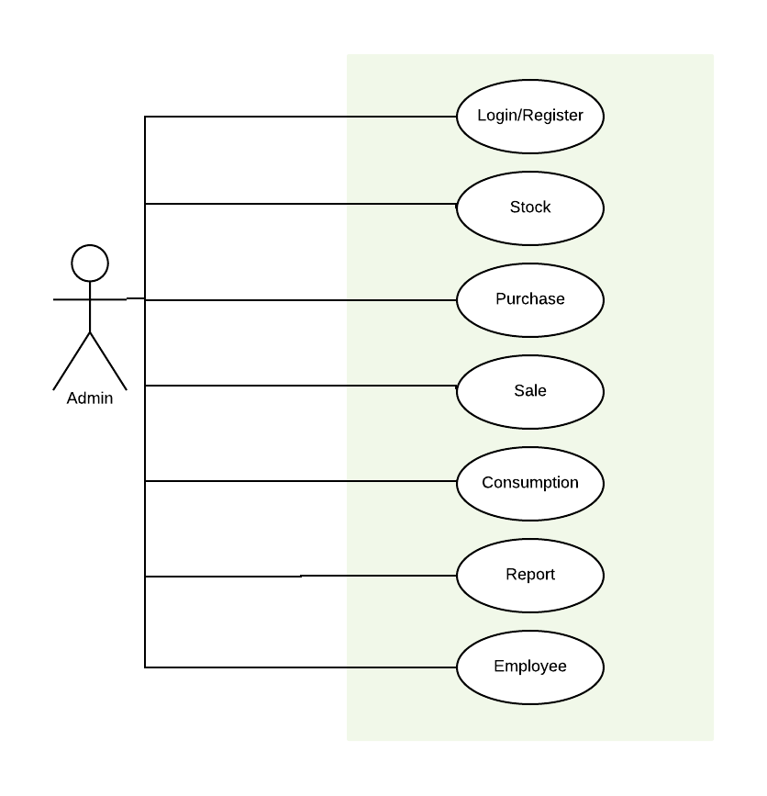

**2.5 Use case descriptions in brief format**

**2.5.1 Login/Register**

|  |  |
| --- | --- |
| **Login/Register** | |
| **Use case ID:** | 1 |
| **Actor:** | Admin |
| **Type:** | Primary |
| **Description** | Admin login/register to access system functionality. |

**2.5.2 Stock**

|  |  |
| --- | --- |
| **Stock Management** | |
| **Use case ID:** | 2 |
| **Actor:** | Admin |
| **Type:** | Primary |
| **Description** | Admin can add type of record and update. |

**2.5.3 Purchase**

|  |  |
| --- | --- |
| **Purchase Management** | |
| **Use case ID:** | 3 |
| **Actor:** | Admin |
| **Type:** | Primary |
| **Description** | Admin can add bird, feed, medicine purchase record and also update. |

**2.5.4 Sale**

|  |  |
| --- | --- |
| **Sale Management** | |
| **Use case ID:** | 4 |
| **Actor:** | Admin |
| **Type:** | Primary |
| **Description** | Admin add and update egg and bird sale record. |

**2.5.5 Consumption**

|  |  |
| --- | --- |
| **Consumption Management** | |
| **Use case ID:** | 5 |
| **Actor:** | Admin |
| **Type:** | Primary |
| **Description** | Admin can add and update the consumption of feed, medicine, bird’s mortality and egg waste. |

**2.5.6 Report**

|  |  |
| --- | --- |
| **Report Generation** | |
| **Use case ID:** | 6 |
| **Actor:** | Admin |
| **Type:** | Primary |
| **Description** | Admin can generate the reports of system activities. |

**2.5.7 Employee**

|  |  |
| --- | --- |
| **Employees Record** | |
| **Use case ID:** | 7 |
| **Actor:** | Admin |
| **Type:** | Primary |
| **Description** | Admin can maintain the employee’s record and salary. |

* 1. **Detailed Use Cases**

**2.6.1. Login/Register**

|  |  |
| --- | --- |
| **Login/Register** | |
| **Use case ID:** | 1 |
| **Actor:** | Admin |
| **Purpose** | Admin registration and login is must to access the application |
| **Overview** | In this case the admin fill the login /register form to access the system. |
| **Type:** | Primary |
| **Pre-Conditions:** | * To login Admin must have Account. |
| **Typical course of Events** | |
| **Actor Actions** | **System Response** |
| 1) Owner of the System will Give Admin user name and password | 2) Admin using that username and Password can access the system |
| 3) After login the admin can register account on its own. | 4) System store register record to database. |

**2.6.2. Stock**

|  |  |
| --- | --- |
| **Stock Management** | |
| **Use case ID:** | 2 |
| **Actor:** | Admin |
| **Purpose** | To add type and update stock records. |
| **Overview** | User can add stock record by adding type and update stock. |
| **Type:** | Primary |
| **Pre-Conditions:** | Admin must be login before to change stock. |
| **Typical course of Events** | |
| **Actor Actions** | **System Response** |
| 1) Add or Update stock | 2) System then store data in database. |
|  | 3) System Stores data and displayed the updated data from database. |
| 4) Check the updated data | 5) System displays data from database to user. |

**2.6.3. Purchase**

|  |  |
| --- | --- |
| **Purchase Management** | |
| **Use case ID:** | 3 |
| **Actor:** | Admin |
| **Purpose** | Managing bird feed and medicine purchase data. |
| **Overview** | In this case admin can give add, update about person from whom we are purchasing. |
| **Type:** | Primary |
| **Pre-Conditions:** | Admin must be login to access System. |
| **Typical course of Events** | |
| **Actor Actions** | **System Response** |
| 1) Admin Click the Purchase button | 2) System Loads the purchase form. |
| 3)Admin add Update or search the Purchase record | 4) System Store the record in database. |
|  | 5) System display the updated record in form of table. |

**2.6.4. Sale**

|  |  |
| --- | --- |
| **Sale** | |
| **Use case ID:** | 4 |
| **Actor:** | Admin |
| **Purpose** | To maintain sale records. |
| **Overview** | In this case Admin can add, Update the sale record and also search record by company name. |
| **Type:** | Primary |
| **Pre-Conditions:** | * Admin must be login * Admin Click the Sale Button |
| **Typical course of Events** | |
| **Actor Actions** | **System Response** |
| 1) Admin visit the Sale form | 2) System bring Admin to Sale Form. |
| 3) Admin can Make Sale | 4) System Store sale record to database |
|  | 5) System then Update record of sale and displayed updated record to Admin |
| 6) Admin can select record and update record | 8) System Store updated record to database |
|  | 9) System then display the updated record to Admin. |

**2.6.5. Consumption**

|  |  |
| --- | --- |
| **Consumption** | |
| **Use case ID:** | 5 |
| **Actor:** | Admin |
| **Purpose** | To manage consumption records. |
| **Overview** | In this case System will manage consumption records and also updated stock records. |
| **Type:** | Primary |
| **Pre-Conditions:** | * Admin must be login * Amin can visit the Sale Form |
| **Typical course of Events** | |
| **Actor Actions** | **System Response** |
| 1) Admin click the Sale Button | 2) System Load Sale Form. |
| 3)Admin make the sale | 4) System store the data in database that Admin input. |
| 5)Admin Update the record | 6) System update data from database and show all record. |

**2.6.6. Report**

|  |  |
| --- | --- |
| **Report Generation** | |
| **Use case ID:** | 6 |
| **Actor:** | Admin |
| **Purpose** | To manage the daily reports. |
| **Overview** | In this case System will manage Stock, Purchase and Sale reports. |
| **Type:** | Primary |
| **Pre-Conditions:** | * Admin must be login * Amin can visit the Report Form |
| **Typical course of Events** | |
| **Actor Actions** | **System Response** |
| 1) Admin click the Report Button | 2) System Load Report Form. |
| 3)Admin Select the date which day report want to see and click the make report button | 4) System make report of that day |
| 5)Admin can click the Print button to print report | 6) System Print the report of that day. |

**2.6.7. Employee**

|  |  |
| --- | --- |
| **Employee and salary record** | |
| **Use case ID:** | 7 |
| **Actor:** | Admin |
| **Purpose** | To manage the employee and their salary record |
| **Overview** | In this case System will manage the employee and their salary record |
| **Type:** | Primary |
| **Pre-Conditions:** | * Admin must be login * Amin can visit the Employee Form |
| **Typical course of Events** | |
| **Actor Actions** | **System Response** |
| 1) Admin click the Employee Button | 2) System Load employee Form. |
| 3)Admin add /update the employee | 4) System store the data in database that Admin input. |
| 5)Admin can make salary | 6) System will store record of salary to a specific employee. |
|  |  |

* 1. **System Sequence Diagrams:**
     1. **Login/Register**
        1. **Register:**

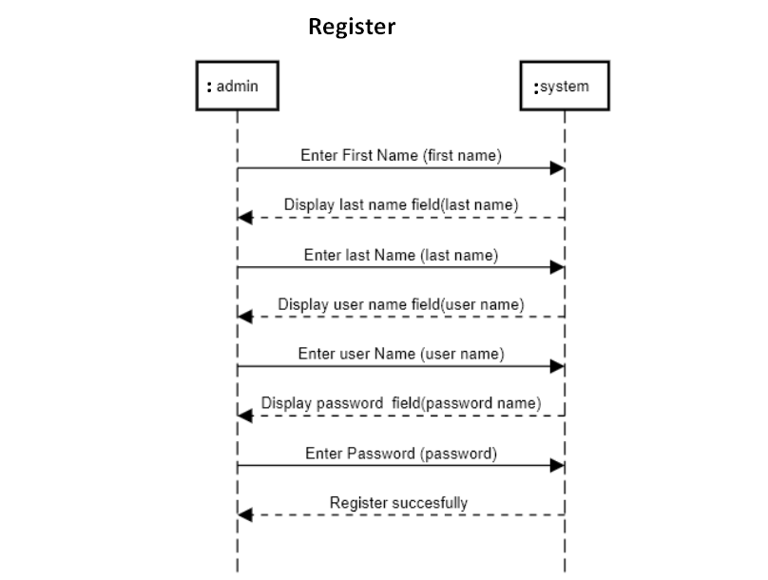

**Figure 2.2 System Sequence Diagram**

* + - 1. **Login:**

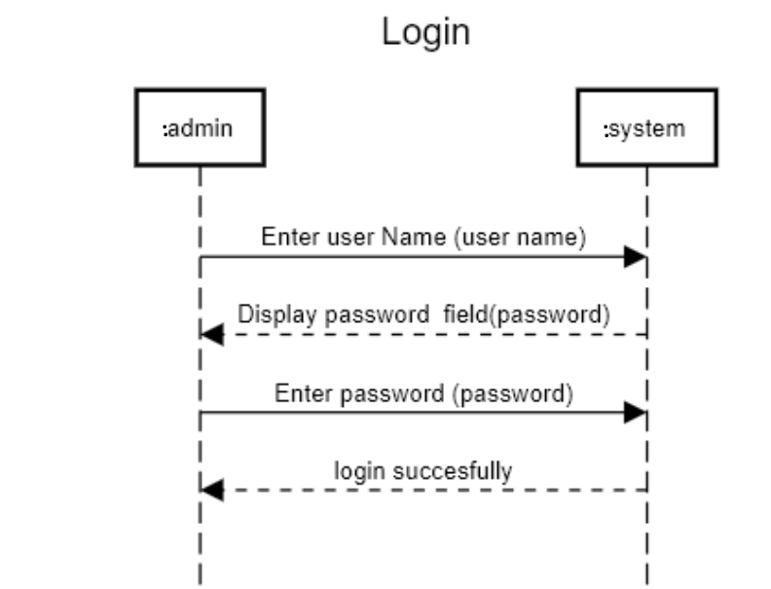

**Figure 2.3 System Sequence Diagram**

* + 1. **Stock Management:**

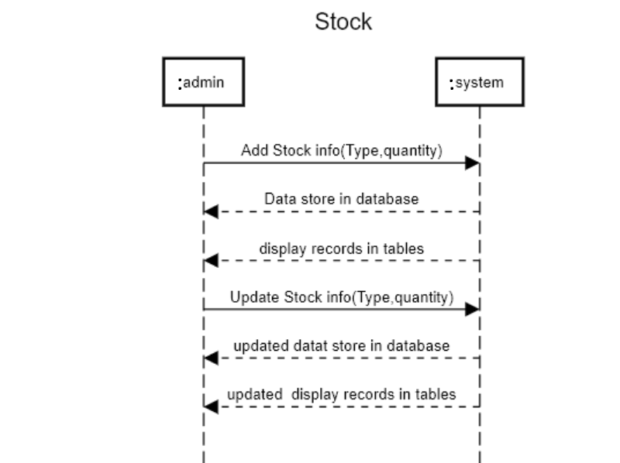

**Figure 2.4 System Sequence Diagram**

* + 1. **Purchase Management:**

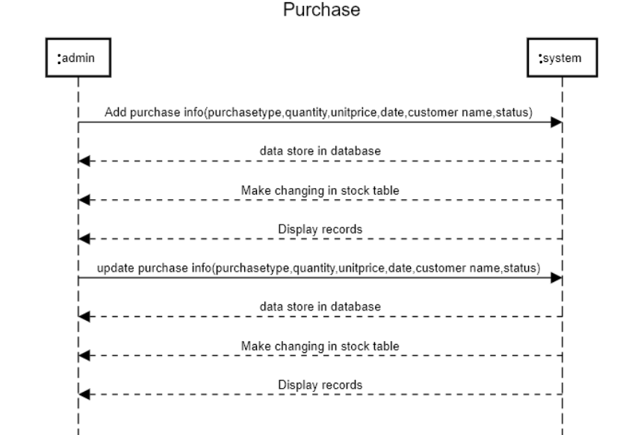

**Figure 2.5 System Sequence Diagram**

* + 1. **Sale Management:**

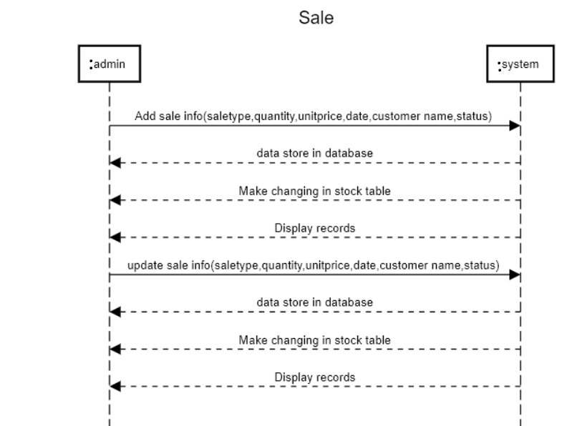

**Figure 2.6 System Sequence Diagram**

* + 1. **Consumption Management:**

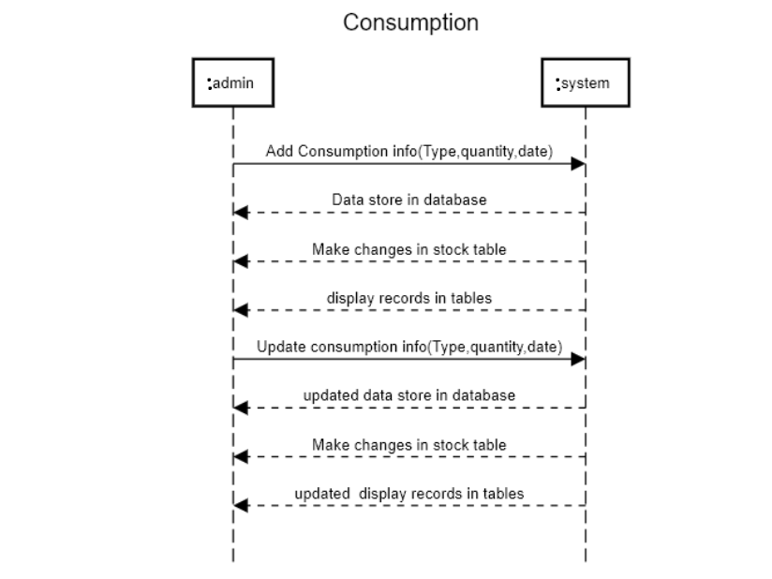

**Figure 2.7 System Sequence Diagram**

* + 1. **Report Generation:**

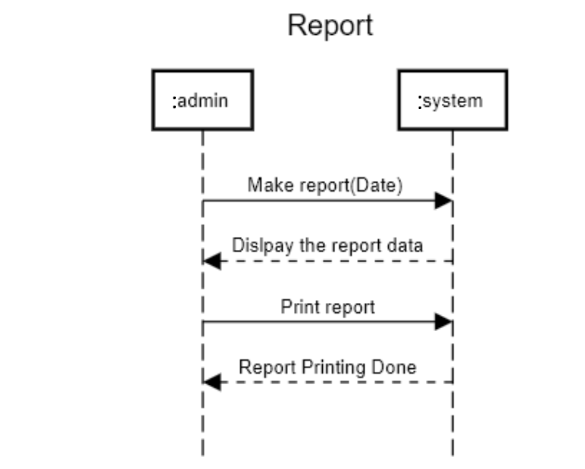

**Figure 2.8 System Sequence Diagram**

* + 1. **Employee Record**

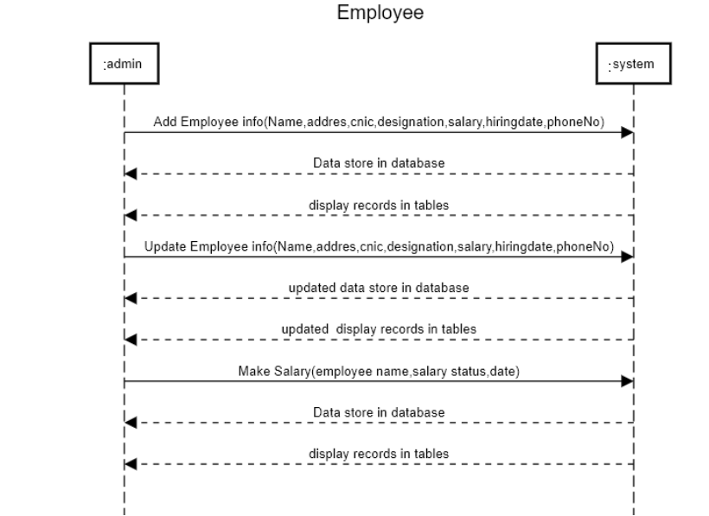

**Figure 2. 9 System Sequence Diagram**

* 1. **Operation Contracts:**
     1. **Login/Register:**
        1. **Enter Username:**

|  |  |
| --- | --- |
| Name | Enter Username(name) |
| Responsibility | Admin request for Login/Register. |
| Type | System |
| Cross Reference | Use Case: Login/Register |
| Exception |  |
| Precondition | * System should be running * For login Admin should have account. |
| Post Condition | An instance of username is created. |

* + - 1. **Enter password:**

|  |  |
| --- | --- |
| Name | enter Password(password) |
| Responsibility | Admin request for Login/Register. |
| Type | System |
| Cross Reference | Use Case: Login/Register |
| Exception |  |
| Precondition | * System should be running * For login Admin should have account. |
| Post Condition | For Login Admin login successful. |

* + 1. **Stock Management:**
       1. **Birds Stock:**

|  |  |
| --- | --- |
| Name | Birds Stock |
| Responsibility | Admin add, update record. |
| Type | System |
| Cross Reference | Use Case: Stock Management |
| Exception | Indicate error if divide by zero. |
| Precondition | Admin should be on the stock management form. |
| Post Condition | Bird’s stock data add/updated. |

* + - 1. **Egg Stock:**

|  |  |
| --- | --- |
| Name | Egg Stock |
| Responsibility | Admin add, update record. |
| Type | System |
| Cross Reference | Use Case: Stock Management |
| Exception | Indicate error if divide by zero. |
| Precondition | Admin should be on the stock management form. |
| Post Condition | Egg stock data add/updated. |

* + - 1. **Medicine Stock:**

|  |  |
| --- | --- |
| Name | Medicine Stock |
| Responsibility | Admin add, update record. |
| Type | System |
| Cross Reference | Use Case: Stock Management |
| Exception | Indicate error if divide by zero. |
| Precondition | Admin should be on the stock management form. |
| Post Condition | Medicine stock data add/updated. |

* + - 1. **Feed Stock:**

|  |  |
| --- | --- |
| Name | Feed Stock |
| Responsibility | Admin add, update record. |
| Type | System |
| Cross Reference | Use Case: Stock Management |
| Exception | Indicate error if divide by zero. |
| Precondition | Admin should be on the stock management form. |
| Post Condition | Feed stock data add/updated. |

* + 1. **Purchase Management:**
       1. **Birds Purchase:**

|  |  |
| --- | --- |
| Name | Birds Purchase |
| Responsibility | Admin add, update, cancel record |
| Type | System |
| Cross Reference | Use Case: Purchase Management |
| Exception | Indicate error if divide by zero. |
| Precondition | Admin should be on the purchase management form. |
| Post Condition | Birds purchase data add/updated. |

* + - 1. **Medicine Purchase:**

|  |  |
| --- | --- |
| Name | Medicine Purchase |
| Responsibility | Admin add, update, cancel record |
| Type | System |
| Cross Reference | Use Case: Purchase Management |
| Exception | Indicate error if divide by zero. |
| Precondition | Admin should be on the purchase management form. |
| Post Condition | Medicine purchase data add/updated. |

* + - 1. **Feed Purchase:**

|  |  |
| --- | --- |
| Name | Feed Purchase |
| Responsibility | Admin add, update, cancel record |
| Type | System |
| Cross Reference | Use Case: Purchase Management |
| Exception | Indicate error if divide by zero. |
| Precondition | Admin should be on the purchase management form. |
| Post Condition | Feed purchase data add/updated. |

* + 1. **Sale Management:**
       1. **Egg Sale:**

|  |  |
| --- | --- |
| Name | Egg Sale |
| Responsibility | Admin add, update, cancel record |
| Type | System |
| Cross Reference | Use Case: Sale Management |
| Exception | Indicate error if divide by zero. |
| Precondition | Admin should be on the Sale management form. |
| Post Condition | Egg sale data add/updated. |

* + - 1. **Birds Sale:**

|  |  |
| --- | --- |
| Name | Birds Sale |
| Responsibility | Admin add, update, cancel record |
| Type | System |
| Cross Reference | Use Case: Sale Management |
| Exception | Indicate error if divide by zero. |
| Precondition | Admin should be on the Sale management form. |
| Post Condition | Bird’s sale data add/updated. |

* + 1. **Consumption Management :**
       1. **Feed Consumption:**

|  |  |
| --- | --- |
| Name | Feed Consumption |
| Responsibility | Admin add, update, cancel record |
| Type | System |
| Cross Reference | Use Case: Consumption Management |
| Exception | Indicate error if divide by zero. |
| Precondition | Admin should be on the Consumption management form. |

* + - 1. **Medicine Consumption:**

|  |  |
| --- | --- |
| Name | Medicine Consumption |
| Responsibility | Admin add, update, cancel record |
| Type | System |
| Cross Reference | Use Case: Consumption Management |
| Exception | Indicate error if divide by zero. |
| Precondition | Admin should be on the Consumption management form. |
| Post Condition | Medicine Consumption data add/updated. |

* + - 1. **Egg Waste:**

|  |  |
| --- | --- |
| Name | Egg Waste |
| Responsibility | Admin add, update, cancel record |
| Type | System |
| Cross Reference | Use Case: Consumption Management |
| Exception | Indicate error if divide by zero. |
| Precondition | Admin should be on the Consumption management form. |
| Post Condition | Egg Waste data add/updated. |

* + - 1. **Birds Mortality:**

|  |  |
| --- | --- |
| Name | Birds Mortality |
| Responsibility | Admin add, update, cancel record |
| Type | System |
| Cross Reference | Use Case: Consumption Management |
| Exception | Indicate error if divide by zero. |
| Precondition | Admin should be on the Consumption management form. |
| Post Condition | Birds Mortality data add/updated. |

* + 1. **Report:**
       1. **Report Generation:**

|  |  |
| --- | --- |
| Name | Report Generation |
| Responsibility | Admin can make reports. |
| Type | System |
| Cross Reference | Use Case: Report |
| Exception | Indicate error if divide by zero. |
| Precondition | Admin should be on the report form. |
| Post Condition | Reports Generate successfully. |

* + 1. **Employee:**
       1. **Employee Record:**

|  |  |
| --- | --- |
| Name | Employee Record |
| Responsibility | Admin add, update, and cancel employee record. |
| Type | System |
| Cross Reference | Use Case: Consumption Management |
| Exception | Indicate error if divide by zero. |
| Precondition | Admin should be on the Employee form. |
| Post Condition | Employee record data add/updated. |

* + - 1. **Make Salary:**

|  |  |
| --- | --- |
| Name | Make Salary |
| Responsibility | Admin make salary record. |
| Type | System |
| Cross Reference | Use Case: Employee |
| Exception | Indicate error if divide by zero. |
| Precondition | Admin should be on the Employee form. |
| Post Condition | Make salary record should be done. |

**2.9 Domain model:**

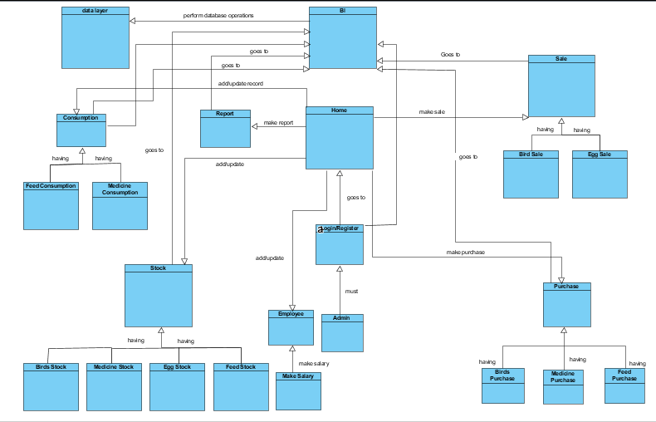

**Figure 2.10 Domain Model**

**2.10 Activity Diagram**

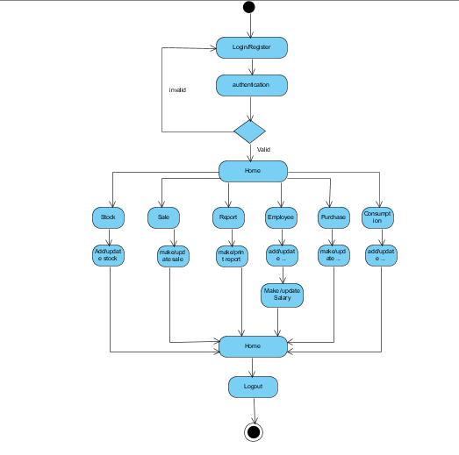

**Figure 2.11 Activity Diagram**

**2.11 Entity relationship Diagram**

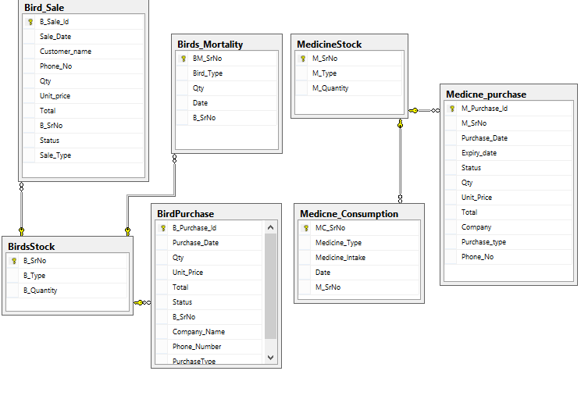

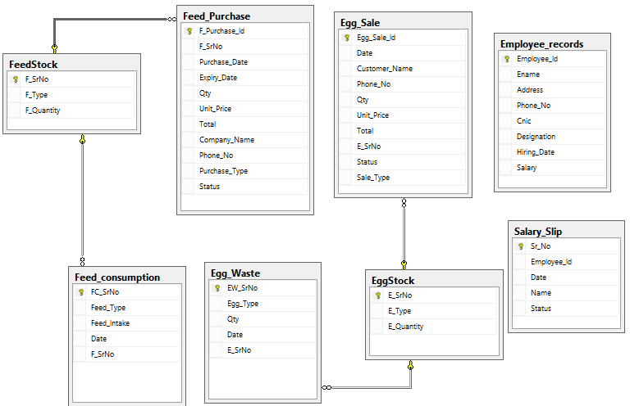

**Figure 2.12 Entity Relationship Diagram**

**CHAPTER 3**

**Methodology & System Design**

**3.1 Methodology**

I have followed the following methodology in the course of my project. The methodology consists of 8 different phases as shown in Figure 1 i.e. First user must be register or login. Next home screen appear multiple button on home screen like. Stock, Purchase, Sale, Consumption, Employee record and Reports. In purchase, stock, consumption, sale module user can add, update record from database and also cancel these activities. IN employee module user can input the employee’s record and also make the salary according to employee designation. Using reports module user can make reports on daily base. I will be discussing each phase in the following sections in detail.

**Login/Register**

**Home**

**Stock**

**Purchase**

**Sale**

**Consumption**

**Logout**

**Reports**

**Employee**

**Figure** **3.1**: Methodology Diagram

**3.2 System Design**

System design is the process of defining system’s architecture, modules, interfaces, and data for a system to meet specified requirements. You can call Systems design as the application of systems theory to product development.

Design highlights a figured course of action that fulfills the necessities, instead of its implementation. For example, a depiction of a database example and programming objects. Plan musings consistently stay away from low-level or "undeniable" unobtrusive components clear to the arranged purchasers. In the long run, layouts can be completed, and the execution, (for instance, code) imparts the real and complete realized design. The term is best qualified, as being object-oriented design or database design.

The system is completely delineated in the analysis model and the system design is the underlying push toward the system design. System Design gives us clear outlines of the system which is then executed. System design results in the following products. A list of design goals, describing the qualities of the system that developers should optimize. Software architecture, describing the subsystem decomposition in terms of subsystem responsibilities, relationships among subsystems, major decisions such as control flow, access control, and data storage.

System design is the transformation of the analysis model into a system design model. In the system design the design goals of the project are defined and the system is decomposed into smaller subsystems. Developers also select strategies for building the system, such as the hardware/software plat form on which the system will run, the persistent data management strategy, the global control flow, the access control policy and the handling of boundary conditions.

The target of system design is to set up a design approach that gives the limits that are portrayed in the system essentials.

Some diagrams are included here to describe the flow of the system:

1. Sequence diagram
2. Class diagram

**3.2.1 Sequence Diagram**

### **3.2.1.1 Login:**

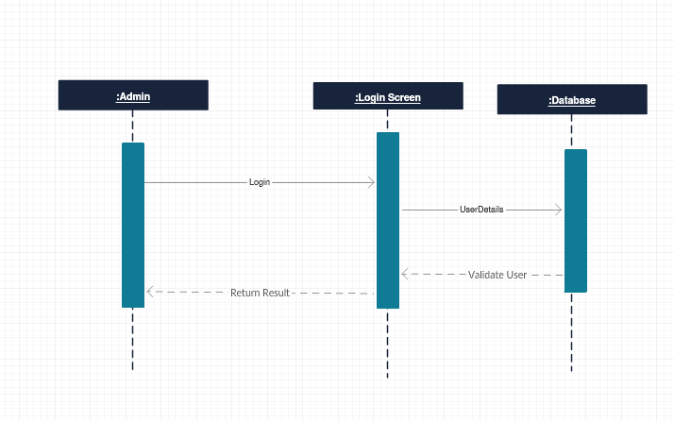

**Figure 3.2 Login Sequence Diagram**

**3.2.1.2 Stock:**

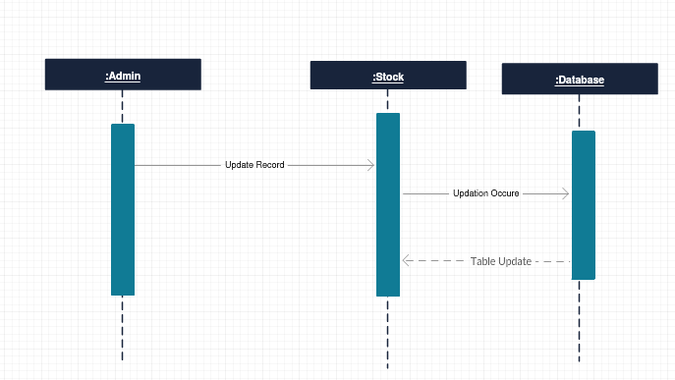

**Figure 3.3 Stock Sequence Diagram**

**3.2.1.3 Purchase:**

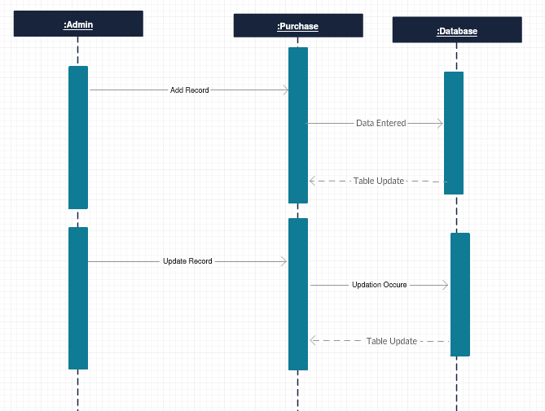

**Figure 3.4 Purchase Sequence Diagram**

**3.2.1.4 Sale:**

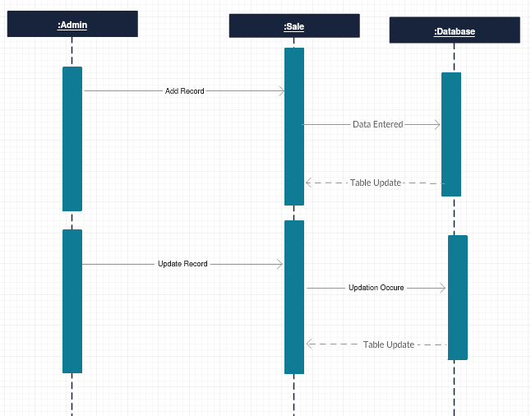

**Figure 3.5 Sale Sequence Diagram**

**3.2.1.5 Consumption:**

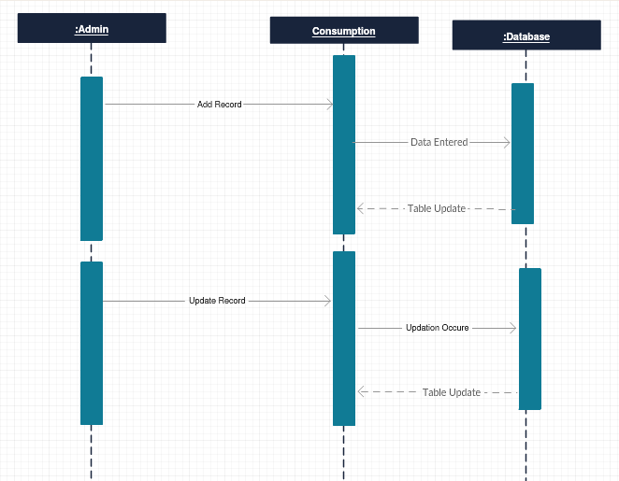

**Figure 3.6 Consumption Sequence Diagram**

**3.2.1.6 Report:**

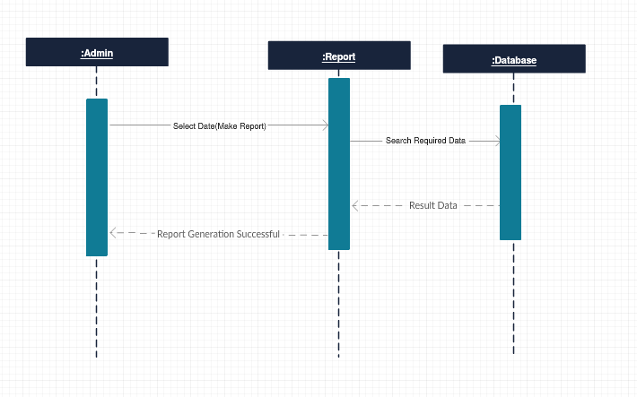

**Figure 3.7 Report Sequence Diagram**

**3.2.1.7 Employee:**



**Figure 3.8 Employee Sequence Diagram**

**3.2.2 Class Diagram**

The class diagram is the main building block of system design modelling. It is used both for general conceptual modelling of the systematics of the application, and for detailed modelling translating the models into programming code. Class diagrams can also be used for data modelling. The classes in a class diagram represent both the main objects, interactions in the application and the classes to be programmed.

In the diagram, classes are represented with boxes which contain three parts.

* The upper part holds the name of the class.
* The middle part contains the attributes of the class.
* The bottom part gives the methods or operations the class can take or undertake.

Class or structural diagrams define the basic building blocks of a model. They are used for static object modeling, describing what attributes and behavior it has rather than detailing the methods for achieving operations.

**Class Diagram**

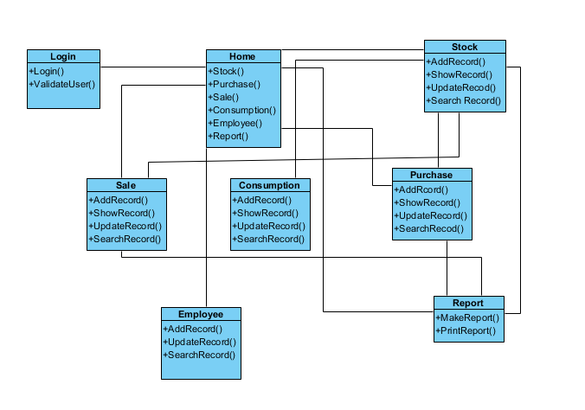

**Figure 3.9 Class Diagram**

**CHAPTER 4**

**Experimental Results& Implementation**

**4.1 Experimental Results**

We did different experiments on our system add multiple data according to system design the system provide full functionality when processing on data. We also use the Tier-Architecture that’s help out to organize multiple classes and data. When you want to make changes any class no effect on other class. Using Architecture we divide the classes into three parts like Presentation, Business and Data Access.

Using this architecture we perform following operations.

* Login/Register(User must login/Register for access the system)
* Stock(user can check the all type of stock and make update if possible)
* Purchase (user can add/update purchase record. In data base data change in two tables like stock and purchase table)
* Sale(when user make sale to add/update record from database changes occur in stock and sale table)
* Consumption(user can add/update consume record from database. decrease the resources from stock table)
* Employee(user can add employee record and also make salary according to his designation)
* Reports generate on daily basis.

**4.1.**1. Login/Register

When user access the system before login/register for use the system. Only authorize person access the system which have register from system. Unauthorized access not allowed to use the system.

**4.1.2 Stock**

Using stock module user can only update the type of stock. User can allowed to change the quantity of the stock from stock table. For example user can add the type of birds like Healthy birds, small birds, week birds etc. and type of eggs like a category Eggs category Eggs etc. and also add the type of medicines and feed. And tables show the all stock type of stock data. We also categorize the stock type of data for user can easily use the stock module

**4.1.3 Purchase**

User can make purchase and add/update data from type of purchase table. Purchase table also categorize into Bird purchase, feed purchase, medicine purchase. User can add type purchase, quantity, purchase date, purchase status, company name, and payment type. For example

User can add purchase type feed, quantity 300 bags of feed, rate of per bag is 2000,purchase statues purchased, company name Badar313 payment type on chash.in this model user not allow to blank the fields when user fill the all fields than purchased don otherwise messages show according to mistakes.

**4.1.4 Sale**

Using this module user can make Sale and add/update data from type of sale table. Sale table also categorize into Bird Sale, Egg sale. User can add type sale, quantity, sale date, sale status, customer name, and payment type. For example

User can add sale type healthy birds, quantity 120, rate of per bird 175 according to his weight, sale status sale done, customer name Punjab meat shop, payment type on chash.in this model user not allow to blank the fields when user fill the all fields than sale don otherwise messages show according to mistakes.

**4.1.5 Consumption**

User can add/update and search the utilize resources. Different type of resources add in different type like Feed consumption, medicine consumption, Egg waste and Birds mortality. User can also search the record from data tables. For example User can add 5 bags of feed use in 25-5-2908.in this model user not allow to blank the fields when user fill the all fields than consumption record add/update otherwise messages show according to mistakes.

**4.1.6 Employee**

In this module user can add/update and search employee data and make employee salary and handle salary record. User can add name of employs address phone number CNIC type of designation and salary. For example employee name Naveed address, Punjab Pakistan, phone number 3030-5566789, CNIC 34101-3344556-7 type of designation System Admin and salary is 35,000.etc. .Constraints apply in this module user not allow to blank the fields when user fill the all fields than Employee record add/update otherwise messages show according to mistakes.

**4.1.7 Report**

This module use for show the reports on daily base or any period. Which reports generate stock, purchase, sale, and consumption and also show the income and expenditure results. Reports generate on the behalf of data. When user select date and click make report button the reports generates automatically. If activity not permit corresponding to date then report show on blank field. For Example user select 18 July 2018 or between another date system generate the report according to this date that’s activates were be done on this date.

**4.2 Implementation**

**4.2.1. System Communication Diagram**

Using Presentation layer user can add data through GUI and this class interact to the business class and send to Data Access layer to perform functionality. Data Access Layer interact to the database and perform work and return to the result and business class also return the result to the presentation layer. You can see on diagram as follow.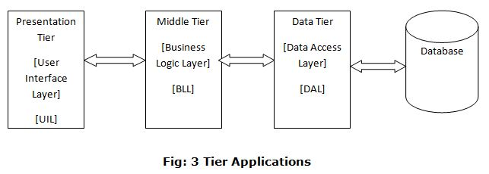

**Figure 4.1 System Communication Diagram**

**4.2.2. Deployment Diagram**

Deployment diagram falls under the structural diagramming family and describes an aspect of the system itself. In this case, the deployment diagram describes the physical deployment of information generated by the software program on hardware components. The information that is generated by the software is called an artifact. This shouldn't be confused with the use of the term in other modeling approaches like BPMN.

Deployment diagrams are made up of several UML shapes. The three-dimensional boxes, known as nodes, represent the basic software or hardware elements, or nodes, in the system. Lines from node to node indicate relationships, and the smaller shapes contained within the boxes represent the software artifacts that are deployed.

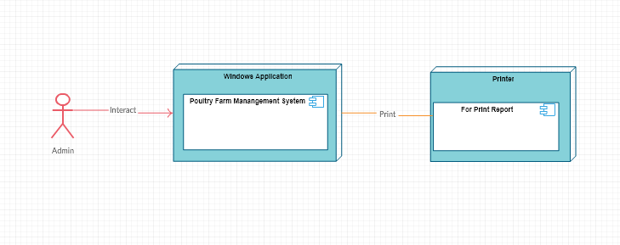

**Figure 4.2 Deployment Diagram**